COLD ASHBY PARISH COUNCIL
AGENDA
Thursday 1st July 2021

An extraordinary meeting will be held on Thursday 1st July at 7.30 p.m.
in the Village Hall, Cold Ashby

Councillors are summoned to attend this meeting of the Parish Council.
Members of the public and press are invited to attend

Agenda

Present: to record the presence of Cold Ashby Parish Councillors, Officers, members of external authorities and others in official attendance at the meeting.

Interests: Members’ attention is drawn to the need to disclose pecuniary interests not already registered before any relevant agenda item.

- Apologies: to receive and consider apologies for absence

- Planning Application: WND/2021/0055: Change of use of the drive to store a mobile refrigeration trailer and mobile milk distribution vehicle on the drive of the dwelling (Stonewold, Crabtree Lane)

Members are asked to agree observations which should reach the planning office by 9th July

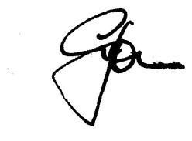

Graham Jones 25 June 2021

